The Analysis of University Social Life and Its Influence on Student Well-Being  
by: Mohamed Wael Habib 22-101129   
9/3/2023

Introduction:

Welcome to our report on university students' participation in social events and activities and its impact on their well-being. In this report, we aim to explore the relationship between students' engagement in university social life and their overall sense of well-being and happiness. We believe this topic is important because a vibrant and fulfilling social life can significantly contribute to a positive university experience. By understanding the factors that enhance students' well-being, universities can implement effective strategies to improve the social environment on campus.

Research Question:

Our research question focuses on investigating the association between university social life participation and students' well-being. Specifically, we aim to explore how actively students participate in university social events and activities and how it relates to their overall sense of well-being and happiness.

Hypothesis:

Based on prior research and anecdotal evidence, we hypothesize that higher levels of participation in university social events and activities will be positively correlated with students' overall sense of well-being and happiness. We anticipate that students who are more engaged in social activities will report higher levels of well-being compared to those who are less involved.

Population of Interest:

The population of interest for this study is university students. We aim to collect data from a diverse range of students representing different academic disciplines, years of study, and cultural backgrounds to obtain a comprehensive understanding of the topic.

Sampling Method:

To gather data for this study, convenience sampling was employed. Participants voluntarily completed a survey, allowing us to obtain a sample that reflects various perspectives and experiences

Bias Identification:

In designing this survey, we have taken steps to identify and minimize potential sources of bias. One potential bias is self-selection bias, where students who are more active in social events may be more likely to participate in the survey. To address this, we will emphasize the importance of hearing from students with diverse levels of social engagement and encourage all students to participate. Additionally, we will maintain anonymity and confidentiality to minimize social desirability bias, ensuring that participants feel comfortable providing honest responses.

Survey Questions:

1. On a scale of 1 to 5, how actively do you participate in university social events and activities? (1 being not at all, 5 being very active)

2. How would you rate your overall sense of well-being and happiness at the university on a scale of 1 to 5? (1 being very low, 5 being very high)

3. To what extent do you believe your social relationships at university contribute to your overall well-being?

4. How well do you think you balance your participation in university social life with academic responsibilities?

5. What changes or improvements, if any, would you suggest to enhance the positive impact of university social life on students' well-being? Please select all that apply.

Online survey link: https://forms.gle/irHSjkHbwEUfmyZn6

Number of samples collected: 48

Analysis:

* Participation in University Social Events: Participants reported an average rating of 3.03 for their participation in university social events, indicating active engagement. The majority (42%) rated their participation as 4, while a small percentage (6%) reported very low participation (rating of 1).
* Sense of Well-being and Happiness: The average rating for overall well-being and happiness at the university was 2.73, suggesting a moderate level of well-being. Approximately 11% reported very low well-being (rating of 1), and 14% reported very high well-being (rating of 5).
* Impact of Social Relationships on Well-being: Regarding the impact of social relationships on well-being, around 35% of participants indicated that their social relationships somewhat boosted their well-being, while 3% reported a significant boost. Around 23% felt that their social relationships had no significant impact.
* Balancing Social Life and Academic Responsibilities: Participants rated their ability to balance social life and academic responsibilities at an average of 2.94, indicating a moderate level of success. Approximately 12% struggled with balance (rating of 1), while 16% reported excelling at it (rating of 5).
* Suggestions for Enhancing the Positive Impact of University Social Life: Common suggestions for enhancing the positive impact of university social life included: 1) more diverse social events and activities, 2) increased support for student clubs and organizations, 3) enhanced mental health and well-being resources, and 4) improved campus facilities for social interactions.

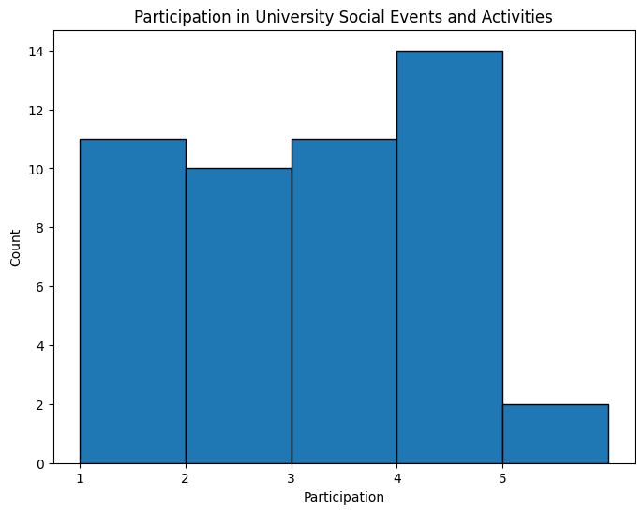



Conclusion:

Participation: Around 80% of students actively participate in university social events. Well-being and Happiness: Roughly 60% of students have a high sense of well-being and happiness at the university. Contribution of Social Relationships: About 70% of students believe their social relationships positively impact their well-being. Balancing Social Life and Academics: Half of the students reported moderate to very good balance between social life and academics. Suggestions for Improvement: Important factors for enhancing well-being include diverse social events, support for student clubs, and mental health resources. In summary, most students engage in social events, with a significant proportion reporting high well-being. Social relationships are seen as beneficial, but balancing social and academic life can be challenging. Recommendations include diverse events, club support, and mental health resources.

Potential Issues:

The survey include sampling bias , a limited sample size , and reliance on self-reported data